Changes and Add New Features
Back-end Part:
- Add menu item as Media for image uploading. As we can view the image url and copy that for inserting in content editor.
- Add menu item as Result for uploading result pdf file. As we can get the pdf url and add this url to content editor for result publishing.
- Change the client’s labels as Partner. ------ ok
- Add a new field for slider as we can add title to each slider. And this title will show in front-end.

-
CMS Menu:
- Increase the height of the editor, change the button name as purpose of this page. ------ ok
- When updating the page then it lost its url slug, then that page does not remain viewable. - ok 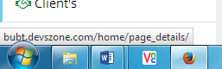
- Image align is not working in editor. -- -- ok
- When updating shows an error message “Page not updated”
- Deleting page without any confirmation message. --- ok
- Still the content of page showing full. This should limited for showing content in admin page.- Ok 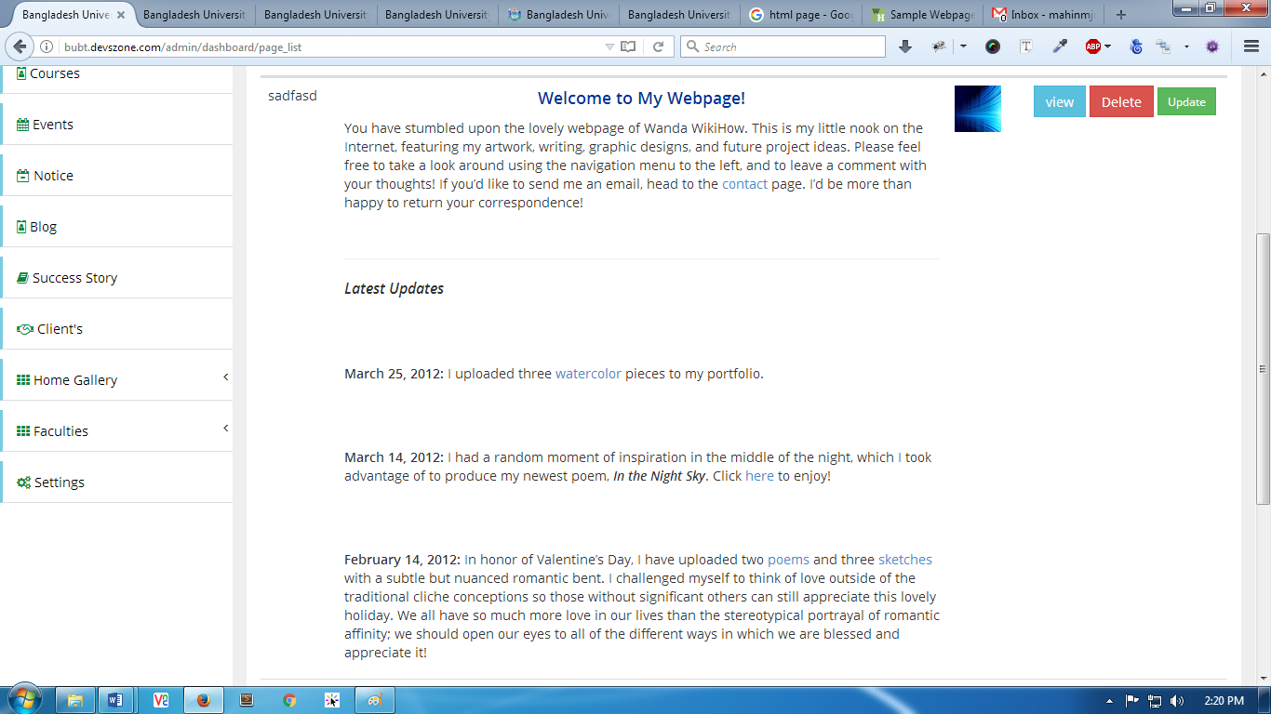
- Sorting not working properly.
- Its broken the design sometime when adding image and html content 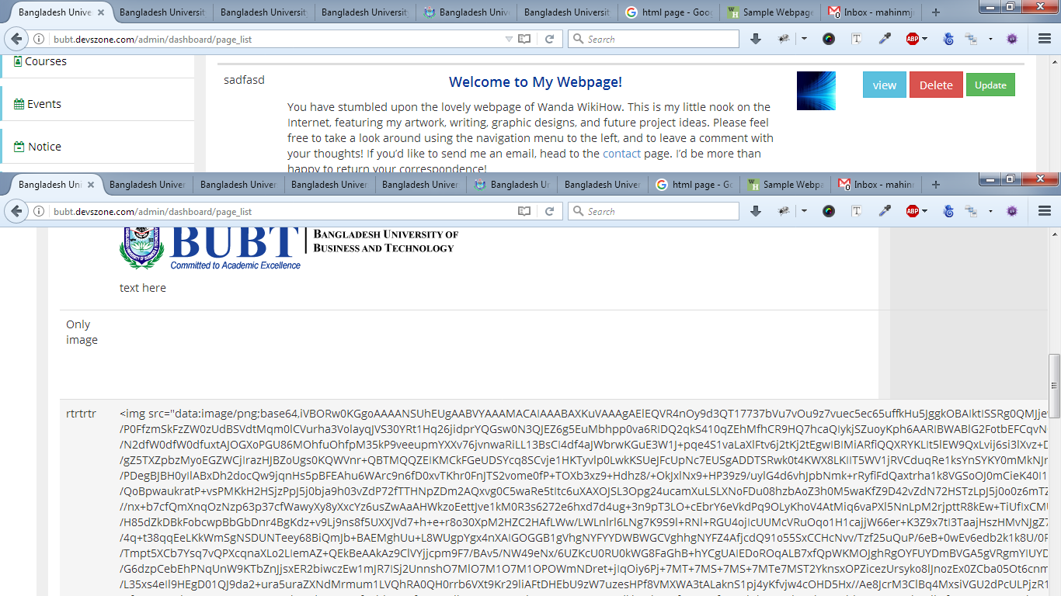
- Add view button to menu page. – ok
- Menu sorting is not working correctly
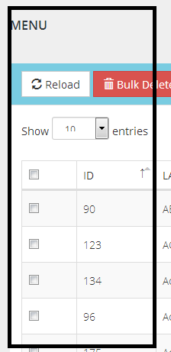

Slider Menu:
- Add cancel button while uploading image.
- Add new field as slider title for while uploading the image.
- There is no confirmation message before deleting the slider image.
- Edit image page design is not looking good at all.

Course Menu:
- Course content in admin page should limited in for showing ---- ok
- Sorting not working

Event Menu:
- In event sorting not working perfect still now. It’s sorting randomly.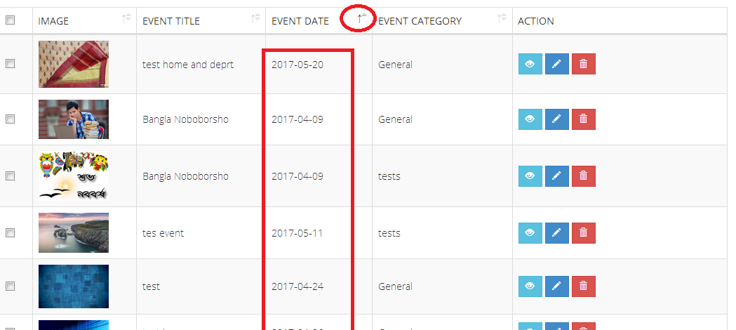

- If I add new event, then it’s not showing in event while selecting on depart category.
- For new event, if select department then which department belong that event?
- If one time occurs the error then it’s still showing error for next new event without refreshing the page
- When updating any event then it lost from the list.
- The new event is not showing this list. I added many events but not showing in this list. 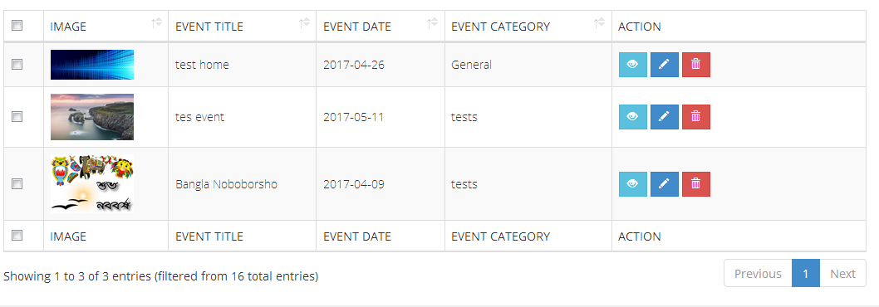
Notice Menu:
- Sorting is not working
- In edit page the content not showing and updates with empty content.
- In notice edit page does not show which notice file is selected
- In edit page the current category not selected

Blog Menu:
- Sorting problem

Success Story Menu:
- Add content editor for each success story because of our success stories have overlay content.
- The content is limited for the main success details. There content should be limited 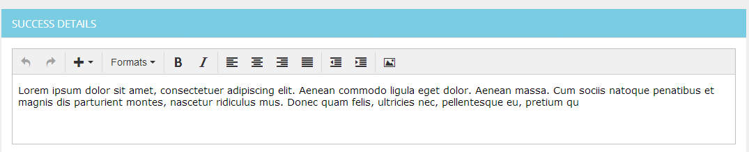
Client’s Menu:
- Rename this menu to Partners -- ok

Home Gallery Menu:
- Disable this menu item now. -- ok

Faculty Menu:
- Still there is normal textarea used in Dean Message section, also in chairman message section. -- ok
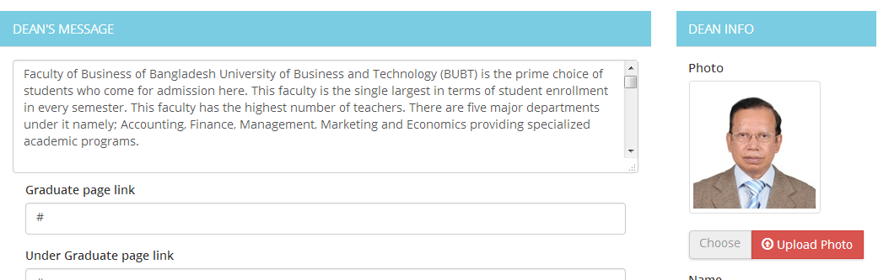
- In dept. highlight menu there is not showing new menu without refreshing page. And add textarea editor for menu details. --- ok
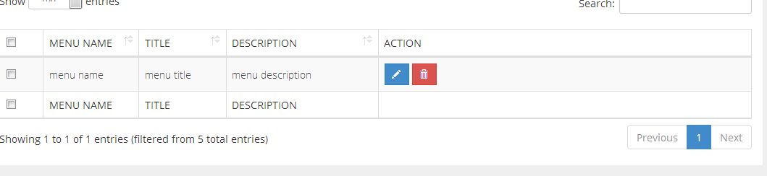
- After adding the department, the modal still shows.
- Duplicate department added to the faculty
- When added any item then it not showing in list.
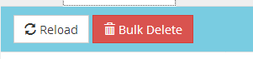
- Reload and bulk delete button not working

- For editing the subject description is not showing -- ok

- The list for curriculum is not showing perfect information as added 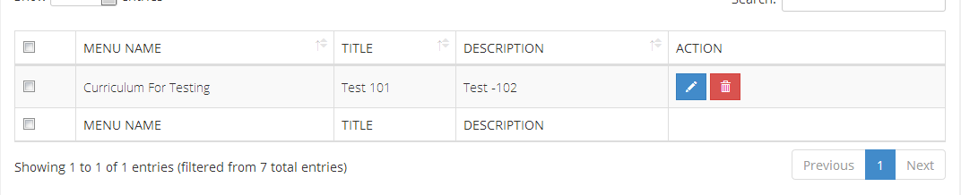

- Achievement Title showing in achievement description. --- ok

- All notice showing department notice section.

- Event also showing in department event section.

Front-end part:
- Still there is fixed image box for page details page.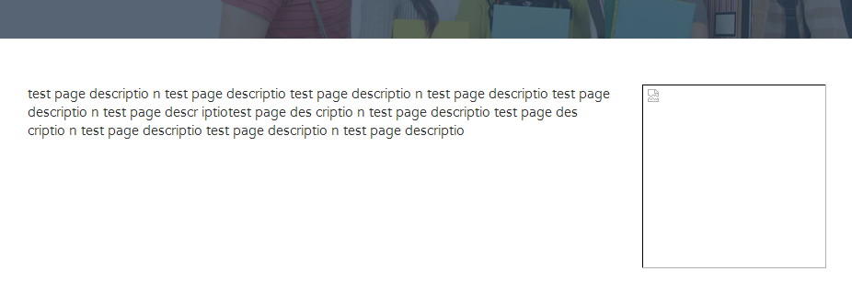
- There is no link for program in home page.
- There are no options for view all event as like view all notice.
- For downloading any notice from front-end then it shows not found error page.
- If added blog post as draft, then that also shows in blog section
- Department background now showing

